**Test Run #1 (normal input)**

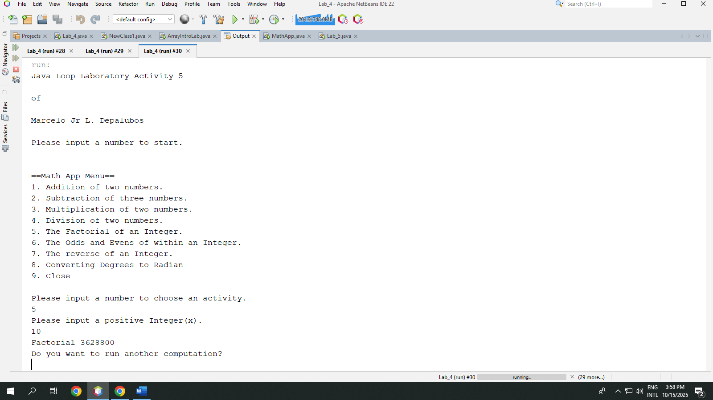

**Test Run #2 (Error input)**

